PTSD
- Follows a traumatic event/s that are perceived to be potentially life threatening
- Recurrent intrusive traumatic memories (flashbacks)
- Sensory cues/triggers
- Intense anxiety
- Attempts to avoid triggers
- Hyper arousal and/or disassociation

Avoidance and exposure
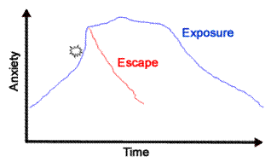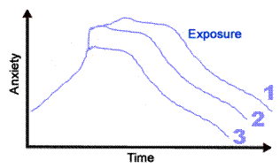

Graded exposure
Cognitive Behavioural Therapy

Trauma therapies

- First phase is stability and therapies that assist function or coping (eg CBT)
- Trauma–focussed therapies address the source of trauma (eg EMDR, psychotherapy or non-verbal therapies.
- Trauma needs to be released in safe, measured ways or re-traumatisation occurs (Babette Rothschild)
- Trauma therapies are ineffective (or even dangerous) while the person is still exposed to the trauma

Art Therapy

- Connects ‘logical’ left brain with ‘emotional’ right brain

Childhood PTSD diagnosis is complicated as there are constant changes in the individual. Many childhood traumas are not included in DSM -5 (like developmental trauma disorder). This may lead to misdiagnosis and mistreatment. Also they are co-morbidity issues (Shmid et al., 2013).

Trauma symptoms include re-experiencing past symptoms. Multisensory mindfulness offer skills to remain in the present. It can help emotion regulation and anxiety symptoms (Vujanovic et al. 2009).

